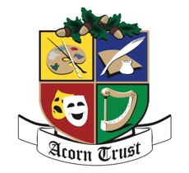

3 August 2026

ACORN TRUST BURSARY

We offer the Bursary Award on the following conditions:

- The sum of $5,000 will be available for your first year of study. If satisfactory passes are gained in all subjects studied during that year a further $5,000 will be paid at the commencement of the second year and, under the same conditions, the third year. In every year the subjects of study must continue to fall within the broard definition of “fine arts” and associated subjects.

- You will provide the Trustees with details of the course you intend to study each year, in the form of an enrolment confirmation. At the end of each academic year you will give us the written results of your study.

- In accepting this scholarship you must agree that your name and photograph may be used in publicity material relating to the activities of the Acorn Trust, both during the term of the scholarship and in subsequent years. A photograph of yourself, suitable for publication in the newspapers and our web site, is to be provided prior to receiving the first grant. A photo sent by email is preferred.

Please sign and return this advice if the conditions outlined above are acceptable to you. Should your application be successful you will be asked to provide a deposit slip for your personal bank account so that the funds can be deposited electronically.

It is set out in the Trust Deed that the Trust income must be applied “….in or towards the benefit of the citizens of the South Wairarapa …..”. Any temporary accommodation necessitated by the place of study being outside the Wairarapa does not negate your eligibility provided your main family home remains within the South Wairarapa area. You will need to advise us if this changes.

ACCEPTANCE OF THESE CONDITIONS:

I, …………………………………….. agree to the terms and conditions detailed above relating to the Acorn Trust Bursary Award.

…………………………………………..
(Signed)

